**POST-PRODUCTION**

**“The Missing”**

**Calise Cottriall**

**CONTENTS**

Script (Draft) 2

Script 5

Shot List 7

Schedule 12

Contingency 13

Sound Logging Sheet 13

Reflection on First Cut 14

Production Log 15

Editing Log 15

Sourcing Sounds 15

Actor's Agreement 16

Editing Table 16

Call Sheet 19

Location Recce 20

Risk Assessment 21

First Cut 22

Final Cut 22

Editing Evaluation 23

NOTE:

*Due to the circumstances of our group initially creating separate ideas, we ultimately ended up picking only one of the ideas to film for the coursework - that being the reason why the contents in this document may not align with my pre-production documents.*

Script (Draft)

Originally, the formation of the script storyline was to have scenes with both Daisy and Freddie at the start and towards the end, it was clear that the only reason we had the character of Freddy is to give context to the audience about Daisy’s situation, so we adapted our original script that’s displayed below to one where we only here Freddy in a voice-over. Additionally, we believed that if we draw more of a focus on the main character Daisy, then the audience could connect to her more and feel more sympathy for her situation. So ultimately, to give context to the narrative, we decided that by adding a voice-over from Freddie will help for audience engagement.

EXT. The side of a road. DAY

The day is cold with a beam of sunlight through the clouds it is drawing closer to winter and the weather is becoming more unpredictable each day.

(Daisy places missing poster on the lampposts everywhere almost covering it she drops her bag placing the rest of the posters in and pulling her worn ledger out, suddenly behind her Freddie appears)

Freddie: (approaching behind to scare her) Boo.

(Daisy jumps reacting not in the way Freddie intended with his playful smile, her face un amused.

Daisy: What are you doing her Freddie? (Walking away from him ignoring any response.)

Freddie: That’s nice daisy! Send your old pal away. Annnd she’s walking away! (He begins to follow her.)

Daisy: Go back to school Freddie!

Freddie: The question is why are aren’t you at school! It’s been 4 months everybody is worried! The teachers the lot of them some angry some concerned. Me! I. incredibly lonely, plus jealous.

Daisy: Jealous of what.

Freddie: All the free time you’ve got to be honest I would be doing something else but-

Daisy: you know what Fred you can be really insensitive (she storms of!)

Freddie: (realising what he has said) Daisy! I’m sorry Daisy… wait!

(Daisy stops. Freddie runs to her!)

Freddie: hold up. I’m really sorry I didn’t mean that. I know he’s still missing but it’s been 12 months daisy we have searched, the police have searched, I know this is hard but maybe (cautiously speaking) I care about you and so maybe you need to move on!

Daisy: I can’t Freddie. we haven’t looked everywhere, look here (avoiding her sorrow.) I did a little digging a week ago and look here, (pulling out newspaper clippings from decades ago) Missing children 1978,1979,1985,1992,2000,2015,2020 all last seen in the same place Darik Forest,

(Suddenly Freddie’s face drops)

Freddie: (Suddenly realising) But billy wasn’t last seen there.

Daisy: That’s correct but his last whereabouts Cheshire hill park 400 metres across from it.

Freddie: A coincidence daisy you’ve got to stop!

Daisy: Is it not possible that he could've walked to it. No Freddie (almost shouting) it is possible and I’m going there.

Freddie: No wait.

Fade out.

**EXT OUTSIDE THE FOREST SOMETIME LATER**

Freddie: How many times daisy don’t go!

Because I’m not going in with you if you do. Don't go screaming my name because a bloody monsters got you!

Daisy: Fine, I won't. (Strong arming her way toward the forest.

Freddie: Not it’s not fine this is crazy!

Daisy: you know what’s crazy Fred that after all this everyone giving up even my parents I’m not going to, I don’t care if this forest is dangerous haunted or containing bigfoot, I am going to look for my brother because no one else will!

(Freddie is silent Daisy turns to the forest and enters)

Freddie: (shouting after her) yeah well! (Muttering to himself) typical girl… I tell her to not go, she goes! (frustrated) I should’ve told her to go.

Fade out

Fade in

**EXT DARIK FOREST**

Cold, wet and dark daisy walks silently through the forest seeming lifeless she crosses streams muddy pathways. She continues to walk forward.

After sometime she looks around seeming to have lost her bearings.

Daisy: Ohh great! Where am I now! (Pulling up a torn map of Darik forest.

Daisy begins to panic she starts to look around quickly with a fright.

A twig snaps daisy peers around frightened.

(The sound of windchimes begin) slowly know where to be seen but Daisy hears them, she gleans around, then a sound whispering

cut to over the shoulder.

Billy: Help me, Daisy!

Daisy: (panicking) Billy! Is that you! Billy!

Billy: Daisy! (SCREAMING)

Daisy: (distressed and crying) BILLY! (screaming)

Daisy turns around towards an opening tall long trees A tall lanky figure standing behind a tree. It’s head slowly reveals its large black eyes. Daisy walks back slowly not breaking eye contact then suddenly many figures stand behind the trees with their heads staring at her at an angle.

She panics turns around a lone tree with a daisy on growing from the ground in front of it. Frozen with fear she moves to face it. Behind her we see a hand come into frame for her shoulder Freddie grabs placing his hand on her mouth so she doesn’t scream.

Freddie: (whispering) Shhh… we are going to walk back nice and slowly… (they move back slowly) and when I say go, we run… okay! Ready go they run as fast as they can straight in the opposite direction Freddie holding her hand and keeping herself safe. They make it out…

Cut to A disfigured alien with a pale hand holding the daisy in a slow and sad caress.

WE FADE OUT.

Script

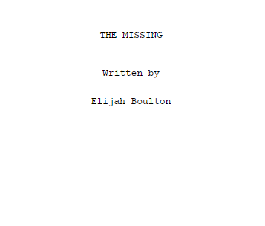

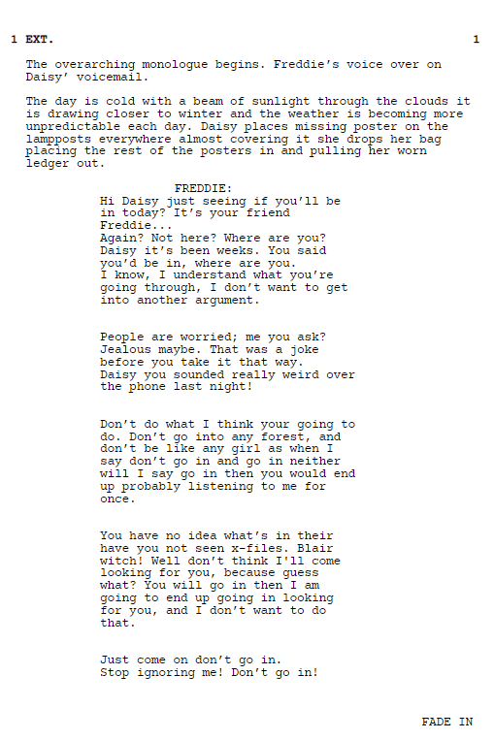

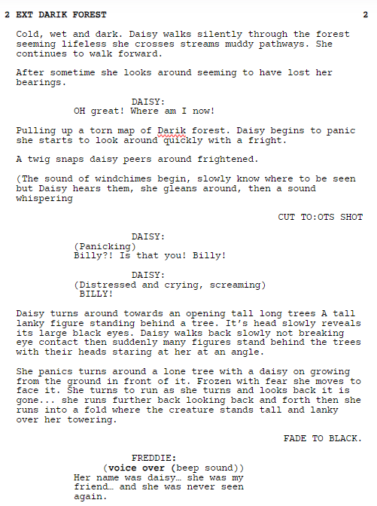SHOT LIST:

|  |  |  |  |  |  |  |  |  |  |
| --- | --- | --- | --- | --- | --- | --- | --- | --- | --- |
| **IMAGE** | **SCENE** | **SHOT** | **DESCRIPTION** | **SHOT ANGLE** | **SHOT TYPE** | **MOVEMENT** | **SOUND** | **LOCATION** | **EST. TIME** |
|  | 1 | 1 | Close up shot of the missing poster before panning out, revealing the title “MISSING” | Eyelevel | CU-MS | Pan | NDS of the phone ringing before | Hadbutt Lane | 13s |
|  | 1 | 2 | Daisy places some cello tape on the missing poster. | OTS | CU | Static | V/O of Freddie leaving a voice mail to Daisy | Hadbutt Lane | 3.3s |
|  | 1 | 3 | Daisy places the missing poster of her little brother on the wall. | OTS | CU | Static | V/O CONTD. | Hadbutt Lane | 9.7s |
|  | 1 | 4 | Places poster on wall before walking away and placing another poster on the wall. | Side Shot | LS/FS | Pan | V/O CONTD. | Hadbutt Lane | 8.2s |
|  | 1 | 5 | She walks away from the wall before continuing on the path. | Long Shot | WS/FS | Tracking | V/O CONTD. | Hadbutt Lane | 5.5s |
|  | 1 | 6 | Daisy makes her way towards Darik Forest. | Eye-Level | WS/FS | Static | V/O CONTD. | Hadbutt Lane | 10s |
|  | 2 | 7 | Confused on where she is, staring down the long path, not recognising it. | Eye-Level | FS | Static | DS of Nature. V/O CONTD. | Astley | 8.9 |
|  | 2 | 8 | Opening the map of Darik forest. | OTS/High Angle | CU | Static | DS of Nature. V/O CONTD. | Astley | 4.4s |
|  | 2 | 9 | Reaction shot of Daisy analysing the map of Darik forest. | Low Angle | MS | Static | DS of Nature. V/O CONTD. | Astley | 4.6s |
|  | 2 | 10 | Dropping her bag near a bush, symbolising her leaving her sense of security behind. | Low Angle | FS | Tracking | Suspenseful music. V/O CONTD. | Astley | 11s |
|  | 2 | 11 | Montage of shots of Daisy heading down the long path, avoiding puddles, making her way into the unknown. | Eye-Level | VWS | Static | Suspenseful music | Astley | 10s |
|  | 3 | 12 | Back shot of Daisy, whilst establishing the environment. | Eye Level | CS | Tracking | Suspenseful music | Astley | 3.4s |
|  | 3 | 13 | Front shot of Daisy walking towards the camera with determination. | Eye Level | CS | Tracking | Suspenseful music | Astley | 5.3s |
|  | 3 | 14 | Daisy walks into the centre frame before stopping and looking at the map and making her way into the forest. | Eye Level | MCU | Static | Music fades out as she enters the frame, before it fades in again. | Astley | 10.7s |
|  | 3 | 15 | Camera pans from front to behind her. As the camera pan stops, Daisy turns her head in shock. | Eye Level | MCU | Pan | Sonar sound. Pre-recorded sound of twigs crunching. | Astley | 13.9s |
|  | 3 | 16 | Establishing shot, showing that even though we heard a noise, there’s no one there. |  | POV/ES | Static | Creepy whistling sounds, creating an eerie atmosphere. | Astley | 2s |
|  | 3 | 17 | Daisy goes to investigate the noise, making her way through the forest. | Eye Level | MCU | Pan | Suspenseful, whistling sound continues, increasing in volume. | Astley | 6.7s |
|  | 4 | 18 | Daisy calling out “Billy!” whilst wondering around in the forest. | Eye-Level | WS | Static | CONT. whistling sound. | Astley | 16.5s |
|  | 4 | 19 | A large tree branch crashes down in front of her, causing her to stop in her path. | Eye Level | MFS | Static | Echoing boom sound, enhancing the shock. | Astley | 2.7s |
|  | 4 | 20 | Close-up of Daisy carefully stepping on the fallen branch. | Low Angle | CU | Pan | Quick classical music fades in, replacing the whistling sound. | Astley | 10.1s |
|  | 4 | 21 | Daisy’s determination showing again as she makes her way through the crowded branches. | Eye Level | FS/WS | Pan | CONTD. Classical music, which fades out towards the end of shot. | Astley | 12.4s |
|  | 5 | 22 | Daisy hears the voice of Billy, she looks around, shouting “Billy?! Is that you?!” | Eye Level | MS | Pan | VO of Billy calling ‘Daisy?’ | Astley | 13.5s |
|  | 5 | 23 | She turns around, with a scared expression plastered on her face. | Eye Level | FS | Static | Disturbing sound to enhance the shock | Astley | 5.2s |
|  | 5 | 24 | A closeup shot, showing her scared expression more. She slowly walks back. | Eye Level | CU | HH | Heart-beat.  Suspense build-up. Breathing of a Neomorph. | Astley | 6.8s |
|  | 5 | 25 | The alien’s appearance gradually fades into the frame. | Low angle | POV shot | HH | Suspenseful music. Breathing of a Neomorph. | Astley | 3.7s |
|  | 5 | 26 | Daisy stares in shock, before she quickly runs away. | Eye level | MS | static | Breathing CONTD. Suspenseful SFX | Astley | 7.6s |
|  | 5 | 27 | Daisy running. | Eye-level | FS/LS | HH | Suspenseful SFX CONTD. | Astley | 2.2s |
|  | 5 | 28 | Daisy running continued. | Eye-level | MS | static | Suspenseful SFX CONTD. | Astley | 1s |
|  | 6 | 29 | Daisy stops in her tracks, looking back to see if the alien is following her. | Eye-level | FS/LS | HH | Suspenseful SFX CONTD.  D sound of bushes rustling. | Astley | 3.5s |
|  | 6 | 30 | Daisy feeling overwhelmed by her surroundings, not knowing where to look. | Eye-level | MCU | HH/Pan | Voice FX(Echo). Suspenseful SFX and rustling CONTD. | Astley | 7.3s |
|  | 6 | 31 | Daisy closes her eyes and takes a deep breath before turning around. | Eye level | CU | Static | Silence. Diegetic sound of breathing | Astley | 4.7s |
|  | 6 | 32 | Daisy turns around, coming face to face with the alien | Side view, eye level | MFS | Static | Suspense shock. DS of wind. Voice FX on scream (Echo) | Astley | 3.6s |
|  | 6 | 33 | Placed in the POV of the alien, seeing Daisy’s scared reaction before she runs away. | High angle | POV/MS | Pan | Suspenseful SFX CONTD. | Astley | 5.1s |
|  | 6 | 34 | Daisy running away from the alien, who watches Daisy before disappearing into thin air. | Eye-level | MFS | HH | Suspenseful SFX CONTD.  DS of actor running. | Astley | 1.5s |
|  | 6 | 35 | Daisy running through Darik Forest. | Knee level/Dutch angle | MS | Static | Suspenseful SFX CONTD. | Astley | 1.8s |
|  | 6 | 36 | Daisy runs out of the wooded area, making her way down the path once again. | Eye-level | FS | HH | Suspenseful SFX CONTD. | Astley | 4.8s |
|  | 6 | 37 | Daisy runs away, with the alien emerging into the frame. | Back shot | WS | Static | Suspenseful SFX CONTD. | Astley | 5.7s |
|  | 6 | 38 | Daisy running out of Darik Forest. |  | WS | Static | Suspenseful SFX CONTD. | Astley | 5.8s |
|  | 5 | 26 | End Credit scene. |  |  |  | Breathing of a Neomorph. |  | 10s |

|  |  |  |  |
| --- | --- | --- | --- |
| **SHOT TYPES:**  WS – Wide Shot  CU – Close-Up  ECU – Extreme Close Up  MCU – Medium Close Up  MS – Medium Shot  MLS – Medium Long Shot  MWS – Medium Wide Shot  CS – Cowboy Shot  MFS – Medium Full Shot  FS – Full Shot  ES – Establishing Shot | **CAMERA ANGLES:**  Eye Level  High Angle  Low Angle  Dutch Angle/Tilt  Over the Shoulder (OTS)  Birds-Eye View  Point of View (POV) | **CAMERA MOVEMENT**:  Static  Pan  Tilt  Dolly  Zoom  Handheld (HH) | **AUDIO**:  Diegetic (DS) – Natural  Non-Diegetic (NDS) – Non-Natural  VO (Voice-Over) |

SCHEDULE:

|  |  |  |  |  |  |  |
| --- | --- | --- | --- | --- | --- | --- |
| **Date** | **Time** | **Location** | **Personnel** | **Props/Equipment** | **Objective** | **Was it executed?** |
| 23/04/2024 | 13.05pm-14:50pm | Hadbutt Lane | Actor Dominik  Director  Camera Operator | Camera  Map  Posters  Cello tape  Bag | All scenes with Dominik | Yes, we were able to carry this out as the weather was appropriate and all the cast was available |
| 24/04/2024 | 9:55am-10:54am | St Mary’s Sixth Form | Editor | CapCut | Creating the first draft for the film. | Yes, all the editing for the footage we’ve collected so far has most got completed. |
| 25/04/2024 | 9:55pm-10:54am | Forest | Actor Dominik  Director  Camera Operator | Missing Posters | All scenes with the alien | Unfortunately, the weather had made us not be able to film with the rain, therefore we couldn’t carry out our production as it would make our film lack continuity with the weather shift and the conditions would’ve been too muddy for us. |
| 03/05/2024 | 13.05pm-14:50pm | Forest | Actor Dominik  Director  Camera Operators | Missing Posters | Final scenes with the alien | Yes, the cast and crew were all available, and we were able to collect all the final footage that we needed. |
| 03/05/2024 | 13:05 pm-14:00pm | St Mary’s Sixth Form | Editor | CapCut | Edit film | Yes, all the editing for this got completed. |

CONTINGENCY PLAN

|  |
| --- |
| **Name:** Calise Cottriall  **Production:** The Missing |
| 1. Weather: If weather isn’t suitable to carry out our shoot, we will reschedule the shoot for another day 2. Equipment: We will have back up equipment at hand such as extra cameras, batteries and portable chargers just in case the equipment fails to operate 3. Location Issues: We have a backup location just in case our original location is unavailable (Lilford Park Leigh) 4. Cast and Crew availability: If one or more cast or crew members are unable to make it to our shoot, we have to be prepared to either reschedule the shoot or have understudies or back up crew members at hand 5. Time Constraints: In case we run out of time to complete a shoot, we can either prioritise filming certain shots or reschedule to film scenes at a later date. |

SOUND LOGGING SHEET

|  |  |  |  |  |  |  |  |
| --- | --- | --- | --- | --- | --- | --- | --- |
| **CUE** | **SOUND** | **SOUND TYPE** | **TIME** | **DUARTION (hr/min/sec)** | **DESCRIPTION** | **SOURCE** | **LINK** |
| 1 | Phone ringing/Phone Call hang-up. | Sound FX | 00.00.00 | 00.00.12 | The phone ringing before being cut off. This is relevant for setting the mood of the film. | CapCut |  |
| 2 | Voice Message | Voice-Over | 00.00.13 | 00.02.26 | Freddy leaving a voice message to his friend, Daisy. This will be relevant to giving the audience some context of the film. | Filming Actor |  |
| 3 | Suspenseful Music  *(November – Memoryhouse)* | Music | 00.00.59    00.01.34    00.01.55 | 00.06.11    00.00.13    00.00.56 | Building up suspense as well as a hint of adrenaline when Daisy is heading into Darik Forest. | YouTube | [https://youtu.be/jldkDrXba OQ?si=qlXPmGl1lmIK93wf](https://youtu.be/jldkDrXba%20OQ?si=qlXPmGl1lmIK93wf) |
| 4 | Sonar sound | Sound FX | 00.02.03 | 00.00.08 | As Daisy turns around to see what the noise were, this faint sonar, sci-fi sound hints to the audience of there being an alien. | Capcut |  |
| 5 | Creepy whistling sound. | Music | 00.02.06 | 00.00.22 | Building horror, synth, tension. This is relevant to the narrative as it meets the horror convention. | Capcut |  |
| 6 | Echoing boom | Foley | 00.02.32 | 00.00.09 | When one of the tree branches fall down, heightening the scare. | CapCut |  |
| 7 | Crunching of twigs | Foley | 00.01.49 | 00.00.04 | Actors walking in the forest builds suspense, making it relevant to the horror genre. | Pre-recorded actors’ footsteps |  |
| 8 | Neomorph’s heavy breathing | Foley | 00.03.10 | 00.00.9 | Neomorph’s presence being introduced | YouTube | <https://youtu.be/OGvwYc-zUx0?si=U3ZpaZ099wqoi4L6> |
| 9 | Shock Sound | Sound FX | 00.03.28 | 00.00.05 | As soon as Daisy starts to run, this shock sound can enhance the audiences’ sense of dread and fear. | Capcut |  |
| 10 | Bushes rustling | Foley | 00.03.36 | 00.00.10 | As Daisy looks around, although she can’t see the alien, she can hear it moving, further increasing the audience's dread. | Pre-recorded shaking the bushes |  |
| 11 | Suspense shock | Sound FX | 00.03.53 | 00.00.01 | Daisy looks up in panic directly at the alien. With this shock effect, this sound is unexpected – just as the alien that appeared was. Therefore, will heighten the audience’s fear. | Capcut |  |
| 12 | Adrenaline build-up | Sound FX | 00.03.57 | 00.00.17 | This quick pace build-up reflects Daisy’s fast-paced movement when trying to escape from the forest, causing the audience to feel more anxious for her. | Capcut |  |

REFLECTION ON MY FIRST CUT:

|  |  |
| --- | --- |
| Positives:   * Got the main scenes filmed. * Clips were in chronological order * Shots mostly matched the screenplay and shot list. * The edited footage being put together allowed me to gain more of a visual aspect on what happens. | Negatives:   * Sound isolation * Since we filmed on two different days that were filmed at different times of the month, the bare branches had now grown leaves and aren’t as bare as they were during the first collection of footage, therefore making it seem like it was set in two different environments. * For the ending scene, we were originally trying to incorporate an alien figure by using grey balloons. However, we noticed that it didn’t look very professional on the camera, and that during the production, the balloon kept on popping due to the pointy branches at our location. Therefore, we’ve decided that we should use an actual figure during the filming, to which we can then edit and use effects to create an alien-like look. However, I had difficulty with editing the alien within the footage since the majority of the filming was done hand-held, so having the alien overlay match the footage pace and movement was time-consuming yet it was achievable. |

PRODUCTION LOG

|  |  |  |  |  |
| --- | --- | --- | --- | --- |
| **DATE** | **LOCATION** | **OBJECTIVE** | **PROBLEMS** | **OUTCOMES** |
| 23/04/2024 | Hadbutt Lane | Film main scenes. (Scene 2,3,4,5 | We didn’t have enough time to finish filming all of the scenes. | We’ve all scheduled for another day. |
| 25/04/2024 | Hadbutt Lane | Film the ending scenes. | It was raining so unfortunately; we couldn’t continue filming. | We rescheduled to another day. |
| 03/05/2024 | Hadbutt Lane | Film the ending scenes. | It was muddy, since it was raining earlier that day. | We all brought some comfortable shoes to wear, as well as sticking to a less muddy area. |

EDITING LOG

|  |  |  |  |  |
| --- | --- | --- | --- | --- |
| **DATE** | **LOCATION** | **OBJECTIVE** | **PROBLEMS** | **OUTCOMES** |
| 24/04/2024 | St Mary’s High | Make first draft of film. | Since we didn’t collect all of the footage yet, I couldn’t finish all the editing. | Placed them all in chronological order, now having the foundation. |
| 26/04/2024 | St Mary’s High | Improve the visuals and audio | Sound: wind and unwanted audio didn’t make the film sound professional. | I reduced the sound and manipulated it so it focused on certain audios. |
| 03/05/2024 | St Mary’s High | Complete the edit. | Since we had left such a time gap with our filming, the environment had changed, causing the footage to be different. | Although this was a problem at first, once I had colour graded to match the footage with each other, it actually helped with enhancing the idea of being lost and unfamiliar with the surroundings. |

SOURCING SOUNDS

YOUTUBE: <https://youtu.be/OGvwYc-zUx0?si=U3ZpaZ099wqoi4L6>  FOOTAGE:

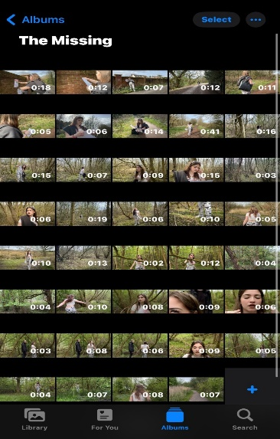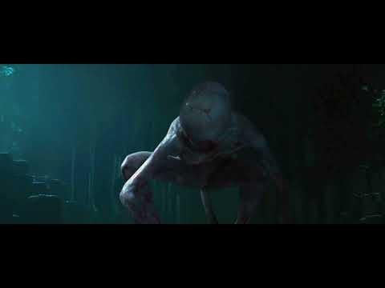

[https://youtu.be/jldkDrXba OQ?si=qlXPmGl1lmIK93wf](https://youtu.be/jldkDrXba%20OQ?si=qlXPmGl1lmIK93wf) (Classical music)

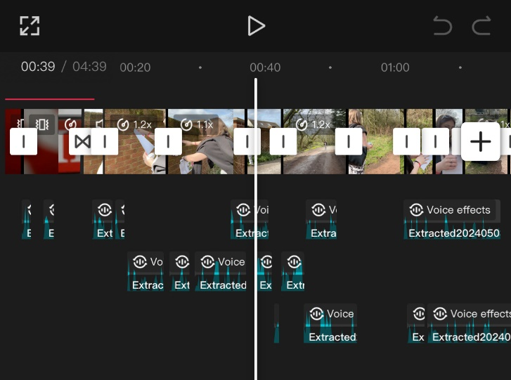CAPCUT:

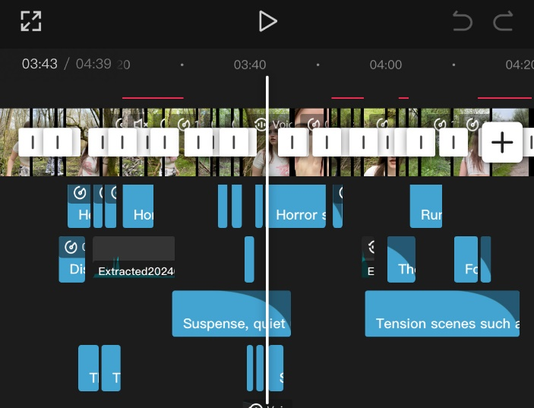

ACTORS’ AGREEMENT CONTRACT

|  |
| --- |
| **Actor’s Agreement Contract** |
| **Title of Unit:** UNIT 10 Film Production |
| **Date:** 22/04/2024 |
| I have agreed to the following: |
| * I have been informed of role as an actor. I will be contracted to work on a film that may possibly be published to YouTube or a festival. * I will be available to work on said dates to shoot. * I will not make any drastic changes to my appearance until after the end of production. * I will be punctual professional and willing when on set. |
| In return the project manager will: |
| * Inform of any time or location changes within 24 hours’ notice in advance. * Will provide a call sheet regarding the schedule 24 hour in advance of filming. * Will provide all make up props and costumes required. |
| Signed Actor: *Dominic Nofit*  Signed project manager: *Elijah Boulton* |

EDITING TABLE

|  |  |  |  |
| --- | --- | --- | --- |
| **Shot** | **Description** | **Edit** | **Justification** |
| **OPENING SCENE:**  **COLOUR CORRECTION:**      **MONTAGE/PACE:**      **COLOUR GRADING:**        **FADE OUT/IN:**        **COLOUR GRADING:**        **ADDING SOUND:**          **ALIEN:** | **OPENING SCENE:**  The opening shot at start of film features the title “MISSING”  **COLOUR CORRECTION:**  Daisy placing some of her belongings into her bag before placing it in the bushes and walking down the path to Darik Forest.      **MONTAGE/PACE:**  Daisy walking down the path leading to Darik Forest.  **COLOUR GRADING:**  Daisy walking into the frame, stopping to look at her map of ‘Darik Forest’ and making her way into the woods.  **FADE IN/OUT**  The transition starts off with full brightness shot of Daisy walking into Darik forest, to which gradually fades into a full black screen - this is known as a fade-out transition. This black screen then fades back to a full brightness shot once again but this time of Daisy looking at her map again.  **COLOUR GRADING:**  Daisy is stepping over the fallen tree branch, reflecting that she’s overcoming her fear.    **ADDING SOUND:**  Daisy seeing the alien for the first time.    **ALIEN:**  An alien appears out of nowhere. | **OPENING SCENE:**  Shot pans back, revealing the entirety of the word “MISSING”. I enhanced the brightness as well as the saturation of the colour “Red”. I clicked on the footage, the tapped on the adjust button to which I increased the brightness before going on the HSL button and increasing the saturation of the colour “Red”.  **COLOUR CORRECTION:**  I enhanced certain colours which I believed would benefit on giving a more vibrant look to this shot. I clicked on the shot, Adjust, then HSL to edit the colours:  Green: *Hue (+1), Sat. (+81), Lum. (+15).*  Yellow: *Hue (+25), Sat. (+66), Lum. (-1).*  Once done, I clicked on the back arrow and clicked on colour, to which I edited Temp, Tint, Vibrance, and Saturation.  **MONTAGE/PACE:**  (A series of shots that condenses time; showing the progression through a sequence of shots.)  I clicked on the shot on the timeline, before I tapped the ‘Split’ button at two different points before clicking the ‘Delete’ button. By doing this, I was able to shorten the full clip into separate different shots even though it’s from the same footage. Additionally, clicked on the speed button, adjusting the speed to be 1.5X faster.  **COLOUR GRADING:**  Adjust, then HSL to edit the colours: Green: *Hue (+1), Sat. (+81), Lum. (+15).*  Yellow: *Hue (+25), Sat. (+66), Lum. (-1).*    **FADE IN/OUT:**  I clicked on the white box that appears in between every clip, before clicking ‘Black Fade’. I then adjusted the time it takes to fade in and out by 0.1s from 3.5s.  **COLOUR GRADING:**  Less vibrancy on the green and yellow of the woods background. I clicked on the adjust button, to then clicking on HSL, which allowed me to manipulate certain colours.  *Green: Hue (-2), Sat. (+93), Lum. (0).*  *Yellow: Hue (0), Sat. (+87), Lum. (-50).*  By decreasing the brightness, exposure, vibrancy, and increasing contrast and shadows, it gives a visual contrast to the beginning scenes, demonstrating a clear shift in setting.  **ADDING SOUND:**  I clicked on ‘Audio’, then ‘Sound FX’. In the search bar, I typed in “Heartbeat”, and found a sound that only lasted for five seconds, which was exactly what we needed, to which it I clicked and it automatically added it to align with the footage.    Furthermore, I clicked on extract and applied the sound of a neomorph alien found on youtube, as well as a classical piece of music known as November – Memoryhouse.  **ALIEN:**  Firstly, I edited the background to fit the horror aesthetic, so that it gives me a foundation on what the alien has to match with. I did this by lowering the exposure, brightness, and enhancing the shadows and contrast. Secondly, we wanted the alien to resemble one of a Neomorph from “Alien: Covenant”, to which we found a clip from YouTube that resembled the desired footage that we wanted.  With this, I added the footage as an overlay, before clicking on “Remove background”, to which it allowed me to edit what part of the YouTube clip that I wanted. Additionally, with the use of this marker, I could adjust the opacity of the alien. By adding multiple markers, I could adjust the opacity without it affecting the whole shot. This same action occurred with the additional alien footage throughout the short film. | **OPENING SCENE:**  Contrasts to the typical horror aesthetic, subverting the audience’s expectations. This can also cause a psychological impact as bright colours evokes a sense of safety, giving the audience a false sense of security before gradually introducing horror conventions, ultimately heightening the impact.  **COLOUR CORRECTION:**  Considering that this is a horror film, I wanted to make the beginning contrast to the horror genre so when we do include horror conventions, it’ll be very clear to the audience that Daisy is somewhere where she isn’t supposed to be. To do this, I enhanced: Temperature (+10), Vibrancy (+8), Saturation (+40). By doing this, it gives off a warmer tone and a more comfort to the audience.  **MONTAGEPACE:**  The original shot of this slow walk lasted for 41 seconds which was way too long, and wouldn’t be good for maintaining the audience engagement. Therefore, by splitting, cutting the clip, and speeding the footage, this condensed the screentime to be only 10 seconds.    **COLOUR GRADING:**  This is the first shift that will be viewed to the audience, implying that Darik Forest isn’t that friendly or appealing. With the dark tones and emphasis on the tree branches looking distorted.  **FADE IN/OUT:**  To demonstrate the passage of time and enhance continuity, I incorporated this transition to aid in indicating a shift within the narrative.  **COLOUR GRADING:**  Wanted to match the horror genre. This supports the narrative as the dark tones of grey can evoke a sense of the unknown and can make an environment feel alien and unfamiliar. Additionally, by taking away the vibrancy and brightness, it gives the impression of a disruption of natural order, hinting at the presence of something unnatural, like an alien entity.  **ADDING SOUND:**  Adding these sounds to this moment is crucial for heightening suspense and having an emotional impact. The heart beating serves as an auditory cue for Daisy’s increasing fear. Originally, the heartbeat sound FX was too slow for my liking, so I sped up to be 1.4X faster, as well as increasing the volume so that it’s more effective for creating unease. Additionally, during this moment of shock, I thought that by adding sound coming from the “unidentified”  Figure would build up suspense.  **ALIEN:**  By making the alien transparent, it meets the element of horror of the audience fearing the unknown. As this suggests that the alien is not fully tangible or comprehensible to Daisy, it adds an unsettling quality. This also allows the alien to blend into the forest and appear unexpectedly, adding a sense of dread and unpredictability – a common convention in horror films. |

Call Sheet

|  |  |
| --- | --- |
| **The Missing** | **Filming date: 23/04/2024** |
| DIRECTOR: Elijah Boulton | CREW CALL: [01942 876417](https://www.google.co.uk/search?ie=UTF-8&oe=UTF-8&q=dam+house&btng=&safe=active&ssui=on) |
| PRODUCER: Calise Cottriall | EST WRAP: |
| LOCATION (S):  Hadbutt Lane  Forest | LOCATION CONTACTS:  WEATHER: N/A |

|  |
| --- |
| **NOTES ON MEETING/PRODUCTION ARRANGEMENTS:** |
| **CREW** |

|  |  |  |  |  |
| --- | --- | --- | --- | --- |
| **NAME** | **ROLE** | **ADDITIONAL** | **CONTACT NO.** | **EMAIL** |
| Elijah Boulton | Director | Props | 0736444**** | Boulton_Elijah@st-maryshigh.wigan.sch.uk |
| Calise Cottriall | Camera Operator | Equipment | 0736444**** | Cottriall_Calise@st-maryshigh.wigan.sch.uk |
| Mia | Camera Operator |  | 0736444**** | Blears_Mia@st-maryshigh.wigan.sch.uk |
| Dominik Nofit | Actor |  | 0736444**** | Nofit_Dominik@st-maryshigh.wigan.sch.uk |

|  |
| --- |
| **RESOURCES** |

|  |  |  |  |
| --- | --- | --- | --- |
| **PROPS** | **RESPONSIBLE** | **EQUIPMENT** | **RESPONSIBLE** |
| Missing Posters, Map, Cello tape | Elijah | Camera | Calise |
|  |  | Lunches | All |

|  |  |  |  |
| --- | --- | --- | --- |
| **WEEK OF** | **Week 1**  **(8th-12th April)** | **Week 2**  **(22nd-26th April)** | **Week 3**  **(29th April-3rd May)** |
| **Preparation** |  |  |  |
| **Shooting** |  |  |  |
| **Published and distributed** |  |  |  |

Location Recces

Forestry area around St Mary’s High School public walk space.

The public walking trails around the school is a public trail and by British law members of the public and the media do not permission or a permit to film or photograph and the police have no lawful way of preventing this from happening.

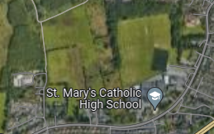

**Address Details:**

Ferndale, Hadbutt Ln, Manchester M29 7FJ

**Access to location:**

Considering that this area is a public area, no permissions are required

= Filming Locations

**Potential Filming Problems**:

**Forest**: Weather Conditions, noise from the nearby road, additional noise (wind, etc), no cover for crew if inclement weather, availability of electricity, lack of access to facilities (e.g., restrooms), presence of bugs/wildlife could interfere with filming process, need to deal with natural light conditions throughout the day

Risk Assessment

|  |  |
| --- | --- |
| Location Contact: | Production Manager:  Calise Cottriall |

|  |
| --- |
| LOCATION, OPERATION OR TASK COVERED BY THIS ASSESSMENT:  Filming in the public forest. |

SIGNIFICANT HAZARDS IDENTIFIED BY THIS ASSESSMENT

|  |  |
| --- | --- |
| HAZARDS | CONTROL MEASURES |
| Poor weather, slippery pathways and working areas | - Wear strong footwear and suitable clothing  - Never run  - Follow safety instructions  - Always have a look out when filming |
| Trip hazards | - Never run  - Follow safety instructions  - Always have a look out when filming |
| Other control measures | - Aware of location of emergency services |

All risks sufficiently minimised/controlled? Y

|  |  |  |
| --- | --- | --- |
| Name of Assessor: | Signature:  E.Boulton  M.Blears  C.R.Cottriall | Date:  12/04/2024 |
| Assessment agreed by tutor or location contact (name): | Signature:  *R.Burns* | Date:  12/04/2024 |

First Cut

[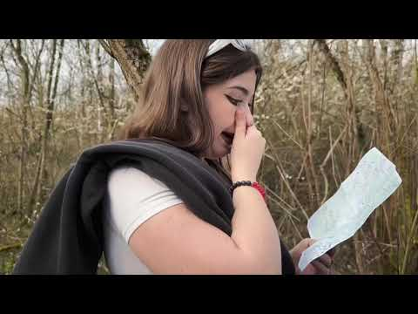](https://www.youtube.com/embed/948bHaP-p5o?feature=oembed)

FUTURE AIMS: In my next edit, I aim at improving the visual aesthetic, footage auditory, transitions, altering the length of some of the longer-lasting clips, and adding a voice-over to keep the audience engaged during the scenes where Daisy isn’t speaking. Additionally, once we’ve got the ending scene footage, there will be more opportunities for me to improve the overall short film.

Final Cut

[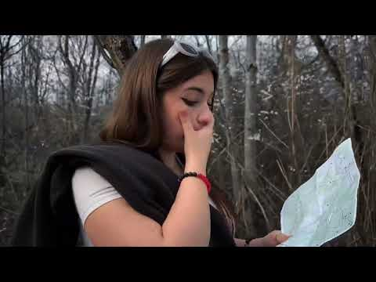](https://www.youtube.com/embed/5daL7I-xIZw?feature=oembed)

Editing Evaluation

The editing techniques utilised in “The Missing” maintains a linear storyline, with the narrative unfolding whilst adhering to horror conventions. Given that the ultimate objective is to make a short film that falls under the horror genre, my group and I believed that prior to undertaking the editing process, we should take into account the editing strategies that are employed in the vast majority sci-fi horror films, which revealed that they tend to concentrate on timing, sound design, and visual effects for building a state of tension, as well as to add more of a hybrid genre between sci-fi and horror.

When contemplating film inspirations, we were intrigued by the way both "Nope" and "Coraline" maintained audience engagement by progressively escalating the level of pressure that the characters were under. Both of these films featured a linear narrative structure, following the narrative of the protagonist throughout – something that we intended to implement into our short horror film as it would be adequate given that we are following Daisy's journey and that a non-linear route wouldn't reflect the narrative's advancement. Seeing as the film “Coraline” follows the narrative based on a young girl, we thought that this would be good to use within our short horror film as the audience will more likely feel sympathy and scared for Daisy is anything occurs – something that was done within the film of Coraline. As well as this, we employed fading transitions that leaves the screen dark to convey that time elapsed during Daisy's walk in the forest.

When it comes to horror films, its important to be aware of the pacing and rhythm of the shots, as any sluggish pacing and abrupt cuts can have the potential to disengage audience members, leaving them less likely to stick around for the main plot. I made sure that this was avoided by maintaining continuity in both visual and audio elements, along with including more suspenseful pacing by leaving pauses right before a jump scare is about to occur. During the editing, there were various shots that lasted for 30 seconds+, which we knew wasn’t necessary to keep all the footage, therefore, by creating a montage out of this one shot, we can save time and increase the audience engagement. By making major cuts, speeding the shot’s time, or combining short snippets of the shot, I was able to not only keep the audience intrigued on what’s going to happen next, it shows a clear contrast between the footage during moments of pause that build up tension before a jump scare.

When considering codes and conventions of horror films, I noticed that in most famous horror films like “Psycho” and “Double Indemnity”, there is a use of voice-overs – something that we wished to incorporate. We believed that this can be used to give context to the audience at the start of the film as without the voice-over, the beginning scenes were just silence. Originally, during post-production, we had recorded 3 minutes worth of voice-overs, yet since we only needed a voice-over to last 50 seconds maximum, we had to cut out a lot of the recording and to keep certain moments. Which although this could be seen as a disadvantage, it worked out in our favour as it allowed for the narrative to get straight to the point without there being too much voice-over that would cause the audience to lose interest.

With lighting in horror films has been utilised to set different atmospheres, but since our film was set outdoors, it made sense for us to just use the natural lighting of the sun through the tree branches as not only does this form of lighting cast natural shadows, it allowed me to play around with light and darkness during the editing process. With enhancing the brightness during the starting scenes to then transitioning to more darkness and increasing shadows, this evokes the sense of the unknown, along with the high and low lighting symbolising the good and bad. Additionally, when filming certain shots, we deliberately wanted to make some footage mirror each other yet having different intentions behind them– this is also known as parallel editing, which this helps add depth and complexity to the film’s narrative structure, as well as allowing the audience to make connections with different shots.

By enhancing certain sounds and making them cross over between each clip allows each shot to connect, making the narrative flow more naturally. With the help of suspenseful pacing and visual storytelling, this helps keep the audience attentive throughout the film. During lengthy timed shots, I cut them down, or any shot that had to stay in but were still somewhat lengthy, I added sound in order to engage the audience’s auditory senses.

With horror films, once you have got the audiences attention, you want to be able to get a reaction out of them in return for attention. I had enhanced the emotional engagement using quick cuts during high-action scenes, tilted camera angles during a shot of Daisy running to show that everything is unknown. Sound design and music allowed me to evoke desired responses from the audience, enhancing the impact during the build-up to jump scares. With using the diegetic sound of nature, it increases the chances of the audience to be immersed into the film, heightening the sense of realism. I did this by already recording footage of the nature, to which I then extracted the sound and adding it on top of the shots. I also incorporated non-diegetic sounds, such as classical music, voice-overs and sound effects. This is beneficial for the film as it heightens the audiences shock factor after all the build-up in suspense. During the filming, we had to consider the visual composition by paying attention to framing, composition, and sequencing so that during post-production, all the shots maintained continuity. To further maintain continuity, I used editing techniques including colour balancing and matching to enhance the professional quality and create visually compelling scenes.

Since our initial storyline was to include an alien, we experimented with trying to have someone act as the alien using a grey balloon to cover over the actor’s face. However, this didn’t turn out to be realistic nor was it scary. Therefore, I decided to try and edit an alien onto the footage as best as I could using the limited resources that I had. Since this is a low-budget short film, I didn’t want to invest so much into the editing as most of the editing software costs £50+, which I didn’t think would be necessary as I wanted to try and incorporate an alien into the footage without spending major things.

With this experimental approach, I decided that I need to find some inspiration for what I wanted the alien to look like, to which I discovered a neomorph, which is a type of alien that’s used within the storyline of the “Alien: Covenant” film. Now that I had my reference of the alien figure, I just had to extract a few seconds of it and place it into the film, so that I could alter it to my own liking. I employed tools such as Splice, Opacity, Overlay, and Outline techniques. With these, I was able to make the alien transparent so that it could blend into its environment, almost looking like a shadowy figure. Even when I adjusted the colour balance for it to blend with the background. Therefore, I thought that the only way that I could make this realistic to suit the environment is for it to become the environment, which allowed more chance for a shock factor to happen with the audience. Having this alien figure within the film acts as a confirmation that this film doesn’t just fall under the horror genre, but also sci-fi.

Overall, I believed the editing process was a success as I was able to utilise my knowledge of the horror genre, employing the codes and conventions so that it would suit the hybrid genre of sci-fi and horror.